Guide for sentiment analysis using PowerBI and MS Cognitive services:

1. Go to <https://azure.microsoft.com> and sign in with the student account.
2. Go to market place from the top menus and go to azure market place.
3. Search for text analytics in market place.
4. Click on text analytics and click get it now. If prompted for signin , do it with your student account.

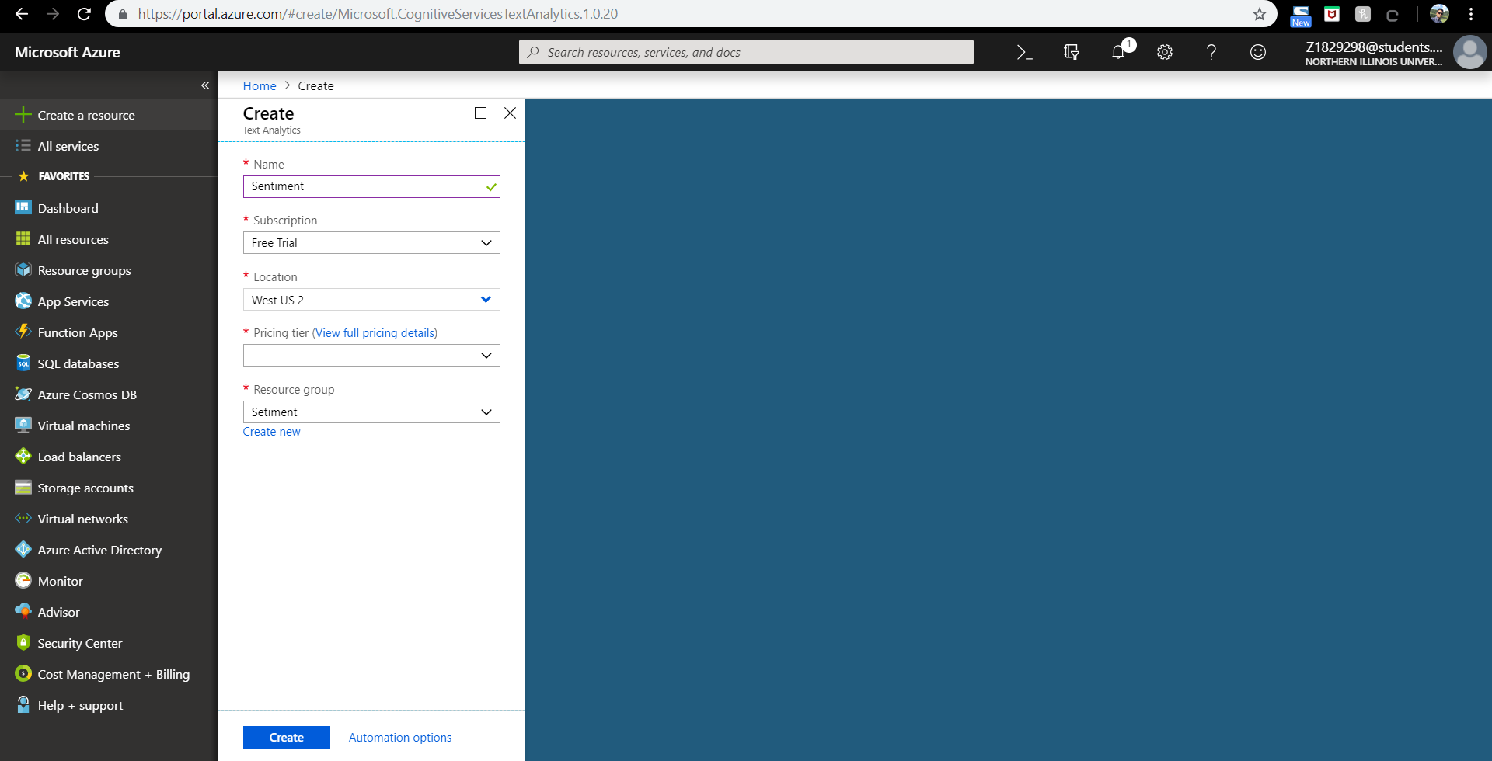

1. Create a resource and fill in details as shown, for pricing tier select F0, which is free for 5000 transactions and click on create.
2. Now go to “All Services” and search for Cognitive Services, you must be able to see the name of the resource created.

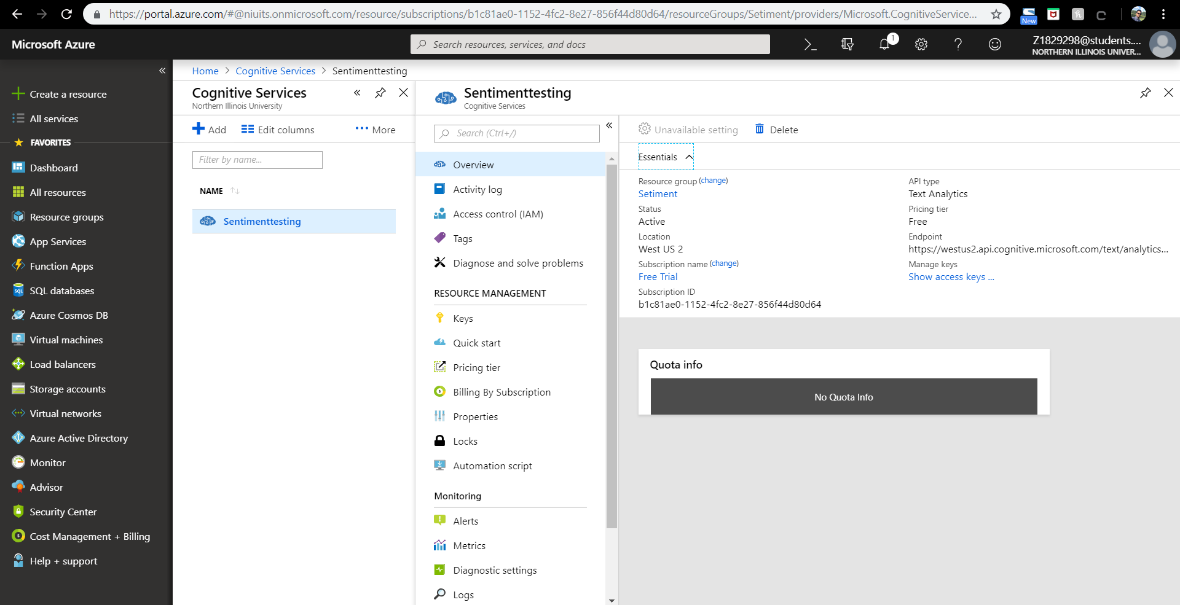

1. In my case it is Sentimenttesting, select it and then click on overview, where you can see the access keys required for us to do the sentiment analysis with powerBI.
2. Click on show access keys.

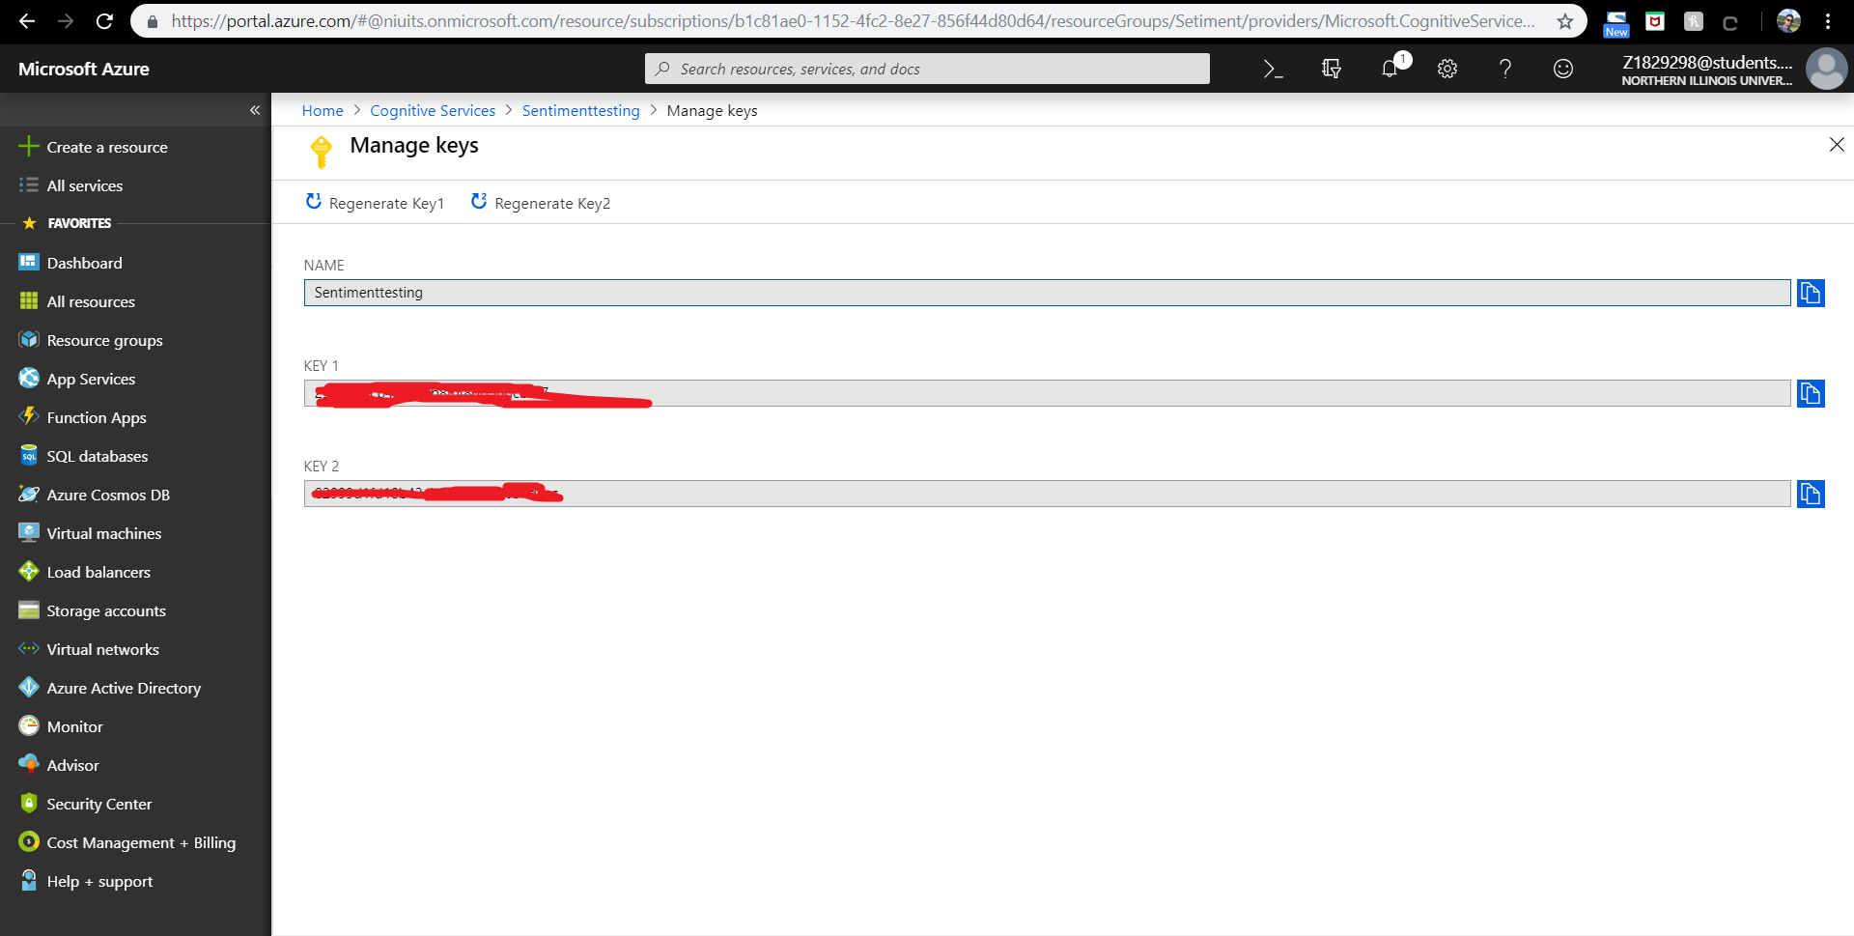

1. Copy one of the keys, I’m copying the first access key and keep it somewhere to use it later.
2. Open your PowerBI desktop, and Click on Home 🡪 Getdata 🡪 Excel and load the excel file attached with this guide, you can generate your own excel sheet with the text column containing the text you want to analyse the sentiment for and an id column with it. I have created an excel containing reviews from several users for the movie “Bohemian Rhapsody” 
3. GO to data view and you must see the screen below.

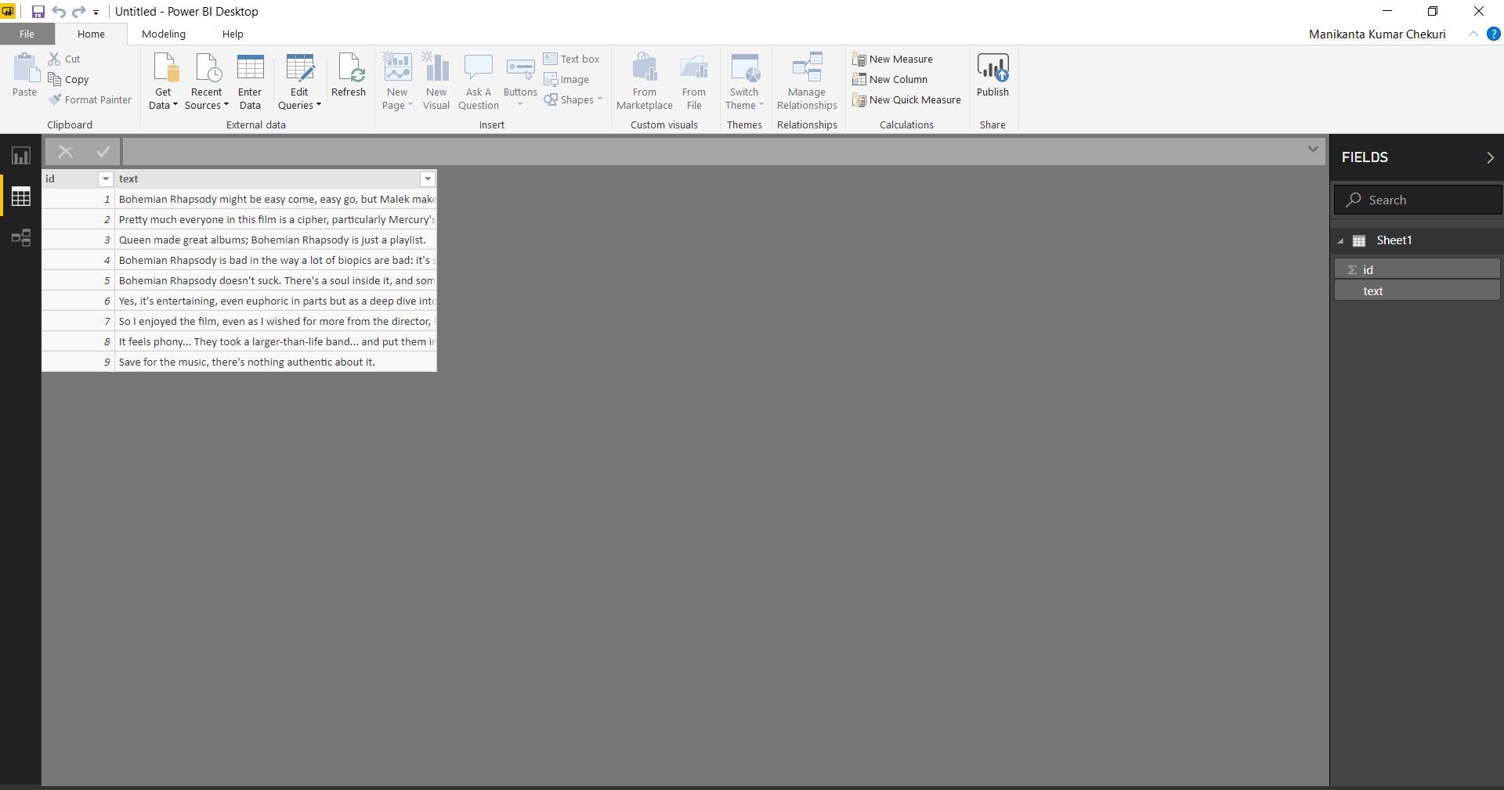

1. Click on Edit Queries 🡪 Edit Queries. The screen below is shown.

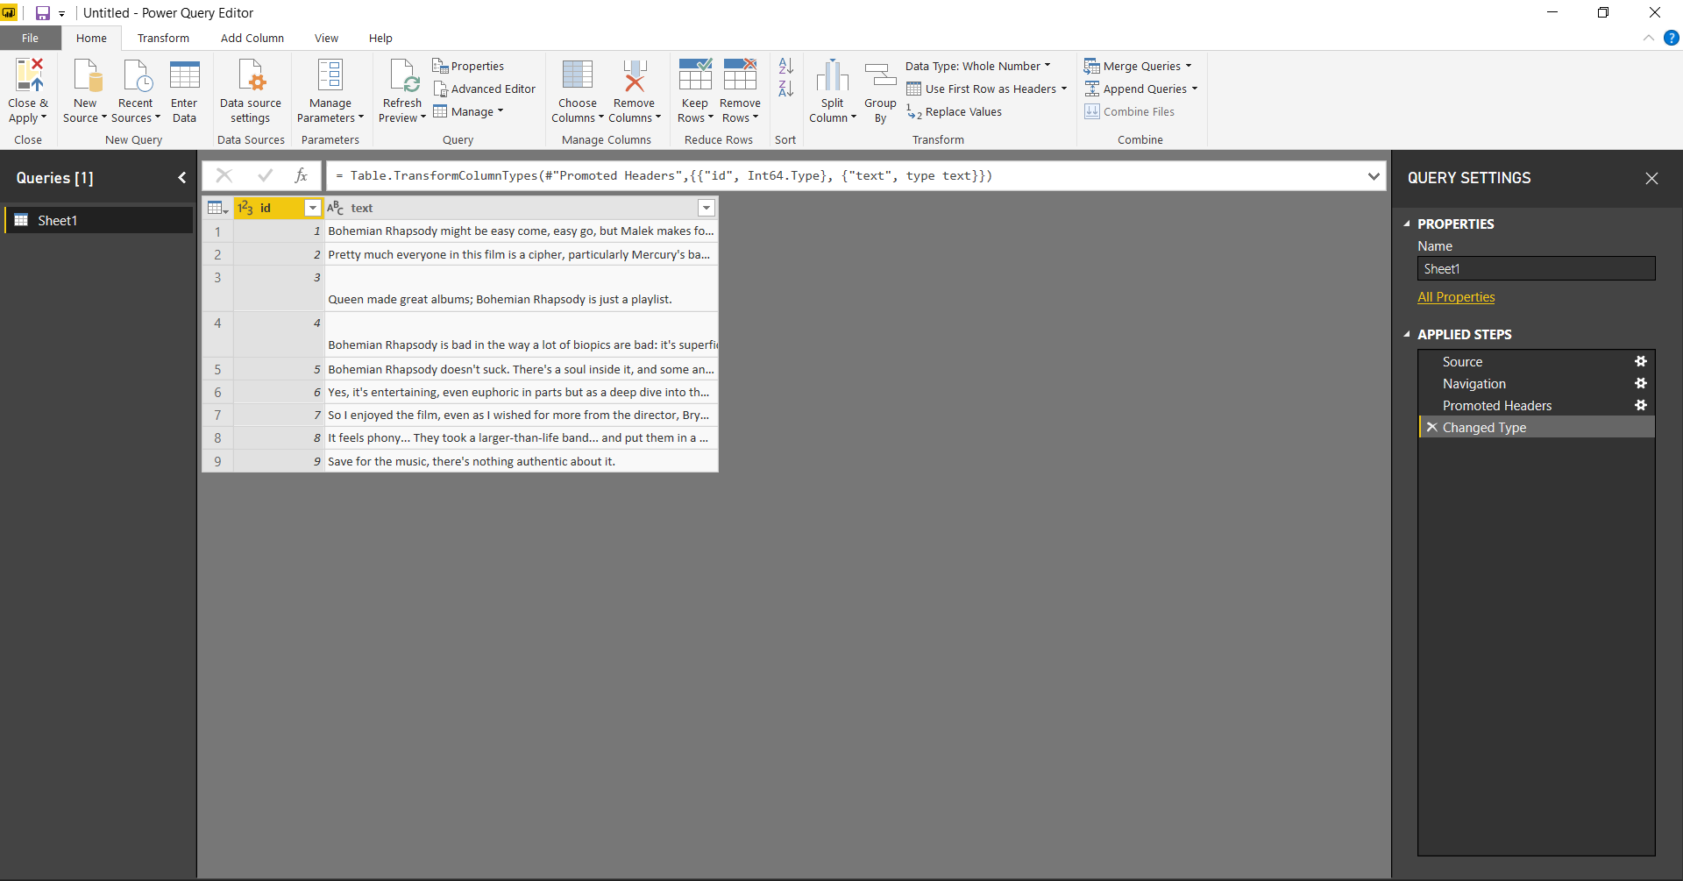

1. Click on Sheet1 and rename to Sentiment. After that right click on the Sentiment file select duplicate and create a duplicate file and call it Sentimenttest. We shall use the duplicate file in order to conduct the analysis and keep the Sentiment file in its original state if required for further use.

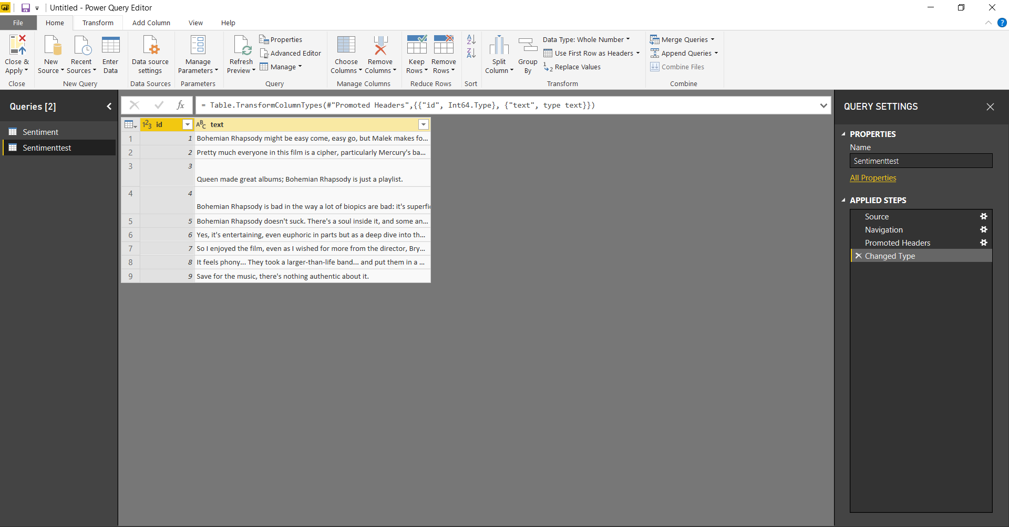

1. Now click on Manage parameters 🡪 New parameter and enter the same values as shown below and under current value copy and paste the API key stored earlier from azure and click OK.

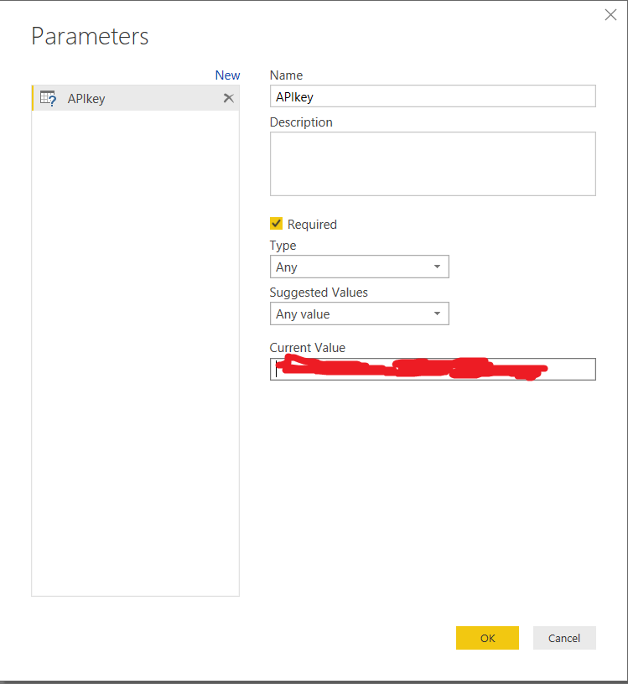

1. An APIkey is created and mapped to Sentimenttest as shown below.

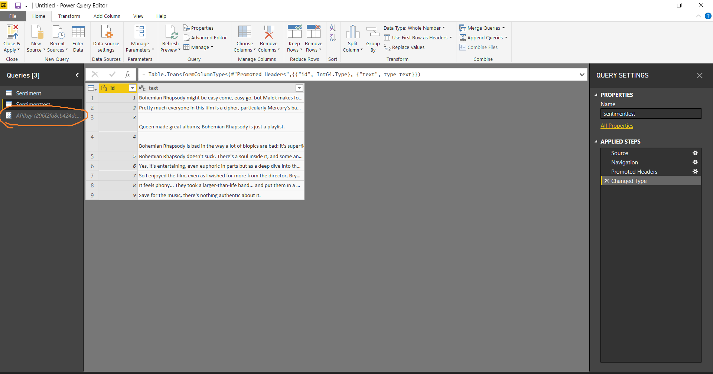

1. Now click on new source 🡪 Blank query and then click on Advanced Editor from Query tab. The below should be displayed.

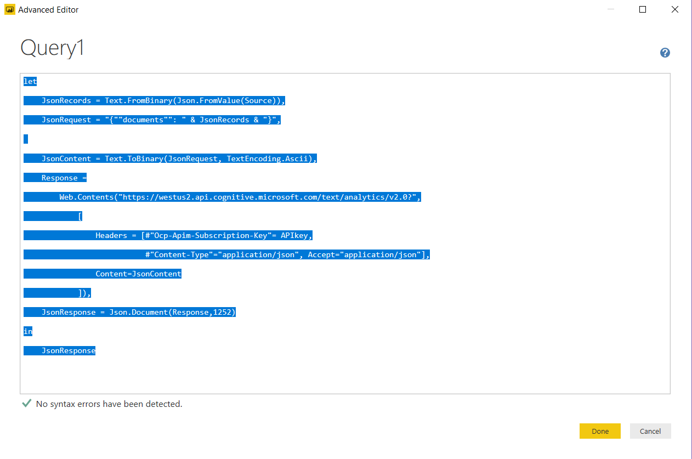

Replace the existing code with one given below and click done, The code is marked in yellow:

(Source as table) as any =>

let

JsonRecords = Text.FromBinary(Json.FromValue(Source)),

JsonRequest = "{""documents"": " & JsonRecords & "}",

JsonContent = Text.ToBinary(JsonRequest, TextEncoding.Ascii),

Response =

Web.Contents("https://westus2.api.cognitive.microsoft.com/text/analytics/v2.0/Sentiment?",

[

Headers = [#"Ocp-Apim-Subscription-Key"= APIkey,

#"Content-Type"="application/json", Accept="application/json"],

Content=JsonContent

]),

JsonResponse = Json.Document(Response,1252)

in

JsonResponse

1. Now click on Sentimenttest🡪Add Column(from the top menus)🡪Index Column and the table changes as below.

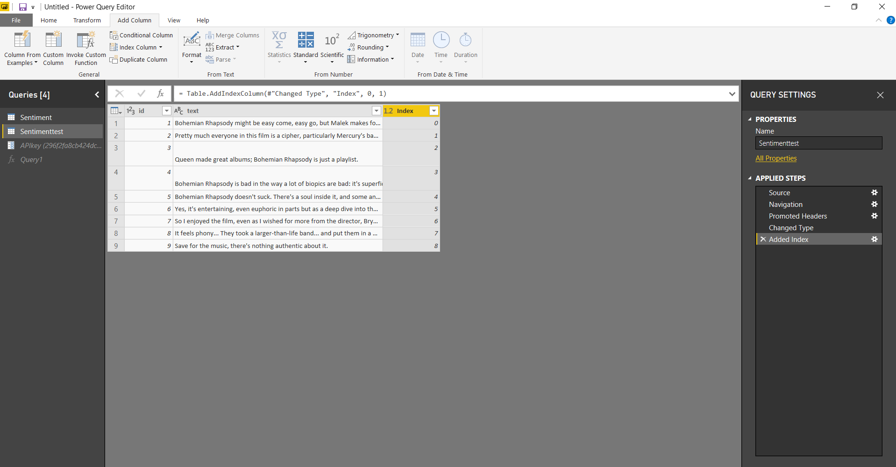

1. In case of huge datasets we need to group by a specific column so we powerBI sends our data to azure in terms of a grouped by column and gets the results. Let us try it even if our dataset is small.
2. After getting the index column, click on Add Column(from top menus)🡪 Standard🡪Divide(Integer). There will be a prompt for value , enter a 10 and click OK, as our data is small.

Usually you can group by a 1000 values if it is a bigger dataset with 1000’s of columns.

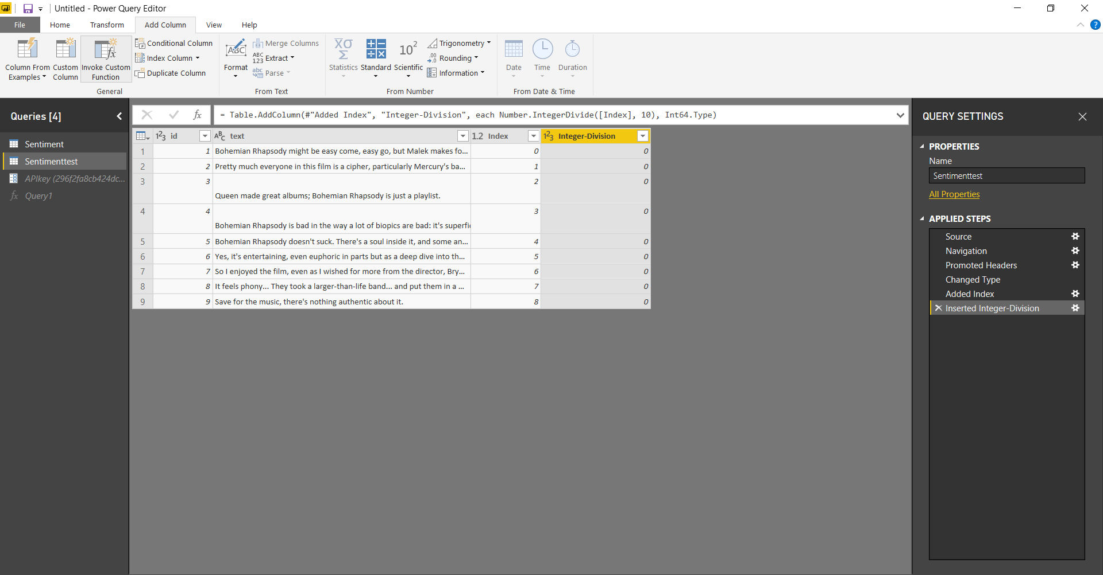

1. Now click on Transform(from top menus)🡪GroupBy, Fill the fields as shown below and click OK.

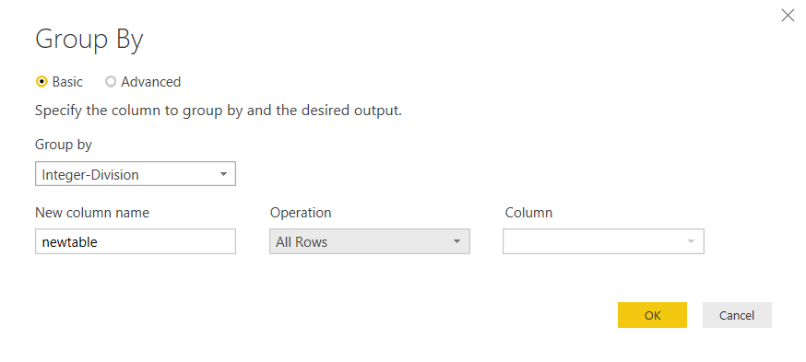

The values must be grouped under a column called newtable as below

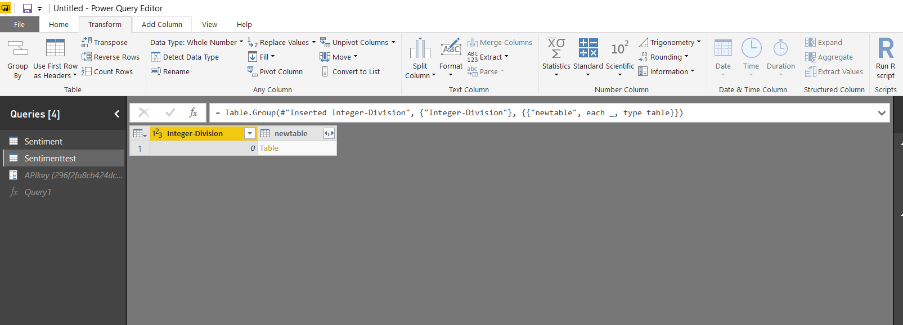

1. We can delete the Integer-Division column as we no longer require it.
2. Now click newtable🡪 goto Add Column from the top menus🡪Invoke custom function.Fill in values as below screenshot and click OK.

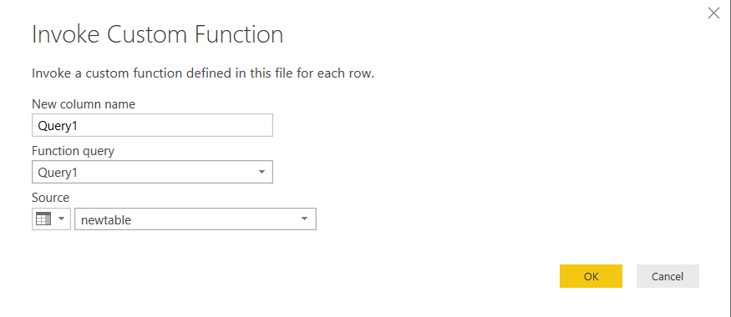

1. You can delete the newtable column as the sentiment resides in the Query1 row and newtable is no longer required.



1. Click on expand button as shown above, just select documents and click OK.
2. Query1.documents table is created, again click on expand button and select expand to new rows.
3. Again click on expand and don’t change anything(i.e keep both the selections id and record) and click OK. The below screen must be shown, the first column specifying the id and second specifying the sentiment of the text (varies from 0 to 1). 1 being the most positive sentiment of the text and 0 being most negative sentiment of the text.

